### 2.2.2 Corporate Office Use Cases

#### The Developer has the following set of use cases:

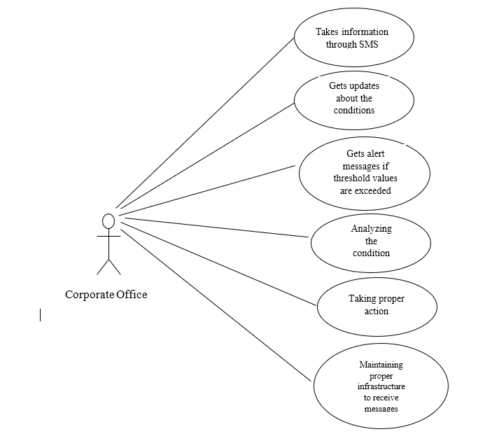

Use case: Taking information Through Sensors

**Diagram:**

Corporate Office

Takes information through SMS

**Brief Description**

The corporate office gathers all the necessary information about the threshold values, which when exceeded should be taken an action.

**Initial Step-By-Step Description**

1. The corporate office collects all the information regarding the threshold values.
2. They keep track of the data to check if the threshold values exceed to take necessary action.

Use case: gets updates about the Drainage condition.

**Diagram:**

Corporate Office

Gets updates about the conditions

**Brief Description**

The corporate office gets updates about the conditions of flow ,gas ,tilt etc.

**Initial Step-By-Step Description**

1. The corporate office gets updates about the Drainage conditions.
2. They can always keep track of the Drainage condition.

Use case: Gets alert messages if threshold values are exceeded

**Diagram:**

Corporate office

Gets alert messages if threshold values are exceeded

**Brief Description**

The Corporate officer gets alert messages in case the threshold values get exceeded or any problem occur.

**Initial Step-By-Step Description**.

1. The GSM module send the alert message to the nearby corporate office
2. The message is sent along with the location.
3. The corporate office receives the alert message along with the condition.

Use case: Analyzing the condition

**Diagram:**

Corporate Office

Analyzing the condition

**Brief Description:**

The corporate Office analyses the problem that has occurred and thinks of the ways to solve it.

**Initial Step-By-Step Description**

1. They analyze the condition that has occurred.
2. They think of the ways to get rid if the condition

Use case: Taking proper action

**Diagram:**

Corporate Office

Taking proper action

**Brief Description**

The Corporate Office takes necessary action.

**Initial Step-By-Step Description**

1. Based on the condition that has occurred proper actions will be taken by the corporate office.
2. They take the information from the SMS and accordingly sends the workers to take necessary action.

Use case: Maintaining proper infrastructure to receive messages

**Diagram:**

Corporate office usecase

Maintaining proper infrastructure to receive messages

**Brief Description**

The corporate Office Maintains proper infrastructure to receive messages

**Initial Step-By-Step Description**

1. Since the GSM module send the messages, proper Infrastructure is maintained by the corporate offices to receive alert messages.
2. They maintain equipment, signal to receive alert messages etc.